Chandrayaan 3: Detection and Identification of Exoplanets in the Deep Space using AI

Gautham Gopan1, M2,

*Department of Computer Science Engineering,*

*SRM Institute of Science and Technology, Chennai, India*

[gauthamgopan10@gmail.com](mailto:gauthamgopan10@gmail.com)

*Abstract*—The integral question, regarding what lays beyond the known horizon has always pondered the curiosity of mankind. This laid the foundation to the search for planets beyond our solar system or in other words Exoplanets. With the advancements of both image capturing and telescopic technologies, we have now access to never ever seen before data, which when combined with the processing capabilities of advance AI, paves way to the discovery of newer Exoplanets out in the deep space. This work mainly focuses on the various techniques that can be used for detection and how their correlations can be better utilized to improve the overall efficiency of the final systems.

Keywords—Exoplanets, Deep space, ,.

# Introduction

There exists exits multiple different techniques that can be utilized for the detection of exoplanets like, studying the radial velocity of planetoidal objects, observing the inter transmittal shadows of planets and so on. Individually many of these techniques have yielded various significant discoveries, but each of these have their own shortcomings.

The basic concept that is habitualized in these processes is the intercorrelation between the exoplanet and its parent star, it is this data that is being analyzed from different angles with different thresholds and parameters that pave way to the above-mentioned methodologies.

Deep space exploration programs have so far resulted in [1] the identification of more than 5514 documented exo-planets and with a significant more number as possible candidates. Various thresholds come into play while deeming a planet as a possible candidate for a viable exoplanet, which includes analyzing the planet's atmospheric properties, orbital properties, proximity to the closest stars and so on. These data points are also taken into account to see if normal life can be sustained on such extraterrestrial bodies.

## The Driving Factor:

The pivotal reason behind the exploration of exo-planets is to seek for existence of possible life beyond our solar system and to also seek for planetary bodies that could sustain life in the future. This search has brought us to finding few such exoplanets that have emulated promising data reflecting their abilities to sustain life. One such planetary body is the Kepler-186f which have showed huge potentials of sustaining life because of its ideal positioning form its host star. Its ideally located in the habitable zone, which is not too close to the host star, but close enough to have atmospheric temperature which is ideal for the existence of moisture. Kepler-186f is also comparable to earth in the terms of planetoidal dimensions which also indicated to the possibility that earth like planets do exist in the deep space and are out there to be explored. Even though the current technical capabilities do restrict us from studying more deeper about the finer details of these exoplanets like their atmospheric configurations and surface integrations, the search for such bodies should be continued on.

The latest advancements in telescopic technologies, with special emphasize to the James Webb space telescope which was launched a couple of years earlier could really help in gathering data regarding the atmospheric compositions of exoplanets. The presence of greenhouse gases like oxygen, carbon dioxide, Nitrogen and so on would give us strong indication of possible life.

## The Relation with SHAPE project

The Chandrayaan-3 module was equipped with an scientific equipment named SHAPE (Spectro-polarimetry of habitable planet earth), which was launched to study Earth form with the lunar orbit. This protocol was designed in such a way that it would mimic the observations od distant exo-planets, by considering earth as a possible candidate for observatory purposes.

## 

1. Concept Diagram

The main role of the module is to analyze and capture the disc-integrated spectrum of the earth and to analyze the polarization signatures from various vantage points from within the lunar orbit there by observing the variations at different phases. By analyzing the thermal spectra, crucial data regarding how variations in the composition of various atmospheric gases in correlation with the shift in seasons effect the thermal emission spectrum of a planetoidal body can be studied. These variations are more noticeable for readings taken from the either pole of the planet, and the variations narrow down as we focus on the equatorial region. The analysis of such data also gives us insights about the surface features of the planets and this same method was used to characterize the rocky structure of the Kepler-186f exoplanet. The analysis of the polarization signature of a planet helps us to identify the presence of clouds in the upper atmosphere if a planet. Both these process where caried out by the SHAPE module, capturing the data with respect to earth as an exo-planet. The observations would be continued to be made at various orbital positions within the lunar orbit.

The main throughputs from the efforts carried out by SHAPE would be that we would be getting an idea about how the data from an earth-like planet is supposed to look like, answering questions like how the disc-integrated spectrum of an earth like planet would look like and how would be the variations in its polarization. This data can be used for future references while observing distant exo-planets, there by acquiring a referential dataset.

Apart from the process discussed above there are five other common methodologies that are used to identify distant exoplanets, and each have their own advantages and disadvantages. Creation of system that could integrate all these five methodologies would be of great impact to systems like SHAPE for future exploration endeavors.

# Analyzing the Individual Methodologies

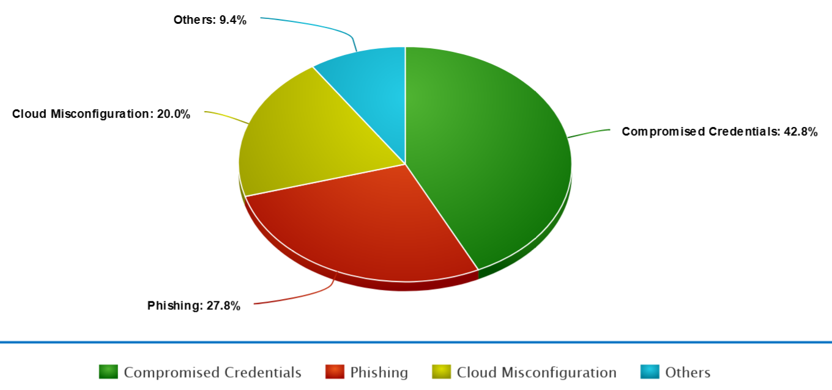

1. Analysis of Attack Vectors

## :The Doppler Method

This method works on the principle that gravity acts both ways, the stars are also under the influence of the gravitational pull of the planets around them, and this happens when both the star and the planet revolve around a fixed center of mass. This gravitational pull results in a slight wobble induced in the stars movement and by observing this wobble of the star it can be deemed that it plays host to a nearby exoplanet, this becomes extremely critical as often the brightness of these stars often envelops the ability of telescopes to identify exoplanets near their vicinity.

The star takes the exact amount of time to complete a full orbit as the planet and therefore by measuring the stars period we can also calculate the period of the planet near them. By using the Kepler’s law, we can calculate the distance between the planet and the center of mass of the system, if the planet is really heavy the center of mass will be a bit closer to it which means that the radius of the stars orbit is bigger. If the time taken to complete the orbit is still lesser, it means that the star is moving at a much higher speed, so thereby by measuring the speed of the star we can calculate the mass of the planet. All these data regarding the velocity and radial path needed to predict the mass of the planet can be gathered by using the doppler method. This method can be used to measure the stars velocity. When observing a star in deep space, it either feels as if the star is moving towards, the observatory point or away from it. By analyzing the spectrum of the light that reaches us, it can be observed that when it seems to be moving towards the point the spectrum is blue shifted and it appears to be red shifted when it moves further away. By measuring how shifted the light coming from the star is, it can be concluded when the star is able to complete a full orbit, thereby providing us the period.

With respect to the earlier relation that, heavier the planet the faster the star’s velocity and thereby more vivid their spectrum is, this is why heavier the exoplanets are, the easier they are to be discovered.

## The Transit Method:

This method works on the principle that if a planet is orbiting around a star at a fixed angle and orientation with respect to the center of mass of the existing system, then the planet is supposed to cross in front of the star during its transition through its orbit. During this process if the light coming from the star is under observation, slight variations in the brightness level will be evident. This variation in brightness if observed over a period indicates the presence of an exoplanet in the observed system. This phenomenon can be compared to what happens during a lunar eclipse when the sun’s light is partially disrupted by the moon. This one of the most successful methods yet in detecting exoplanets.

By using this method, the radius of the exoplanet can be calculated by subtracting the area of light that is being dimmed out from the overall area of the light source. In mathematical terms this can be deduced as the change in flux, or the brightness of the star is equal to the square of the radius of the exoplanet divided by the square of radius of the star. By rearranging this equation, we can calculate the radius of the exoplanet by knowing the amount of brightness reduced and the radius of the star.

## The Direct Imaging Method:

Majority of the exoplanets that we know today have been identified using the above mentioned two techniques, irrespective of that fact with the advancement of telescopic and advance imaging methods newer ways of exploring such distant planets are being developed, one such method is Direct imaging. In accordance with all the planets in our solar system, which do not produce any light of their own, but rather reflect the light of their star. Similarly, exoplanets also reflect the light of their stars, this light can be detected by taking direct images of such planets, but unfortunately due to the huge glare generated by the stars, the light reflected of these planets often go unnoticed. This is where the application of a coronagraph comes into play, this device help in blocking much of the glare of the parent star, making light reflected of the planets more visible during direct imaging. The planet 2M1207B, which was found orbiting around a brown dwarf star was the first exoplanet to be found by using this method. The only hindrance to this method is often while attempting to block out the glare of the parent star, the reflected light of from the planet also gets engulfed in the spectra of the coronagraph.

Direct imaging can also be used to analyze and monitor the orbiting of the planet around the parent star. The further advancements in this technique will aid in understanding more deeper about the atmospheric patters, presence of oceans, and even land masses on these exoplanets.

## Gravitational Microlensing Method:

This concept works on the principle that a heavier star or planet bends the space fabric around it causing the light that’s passing through their system to be brightened for a period of time, this variation can be noticed as a small blip in the brightens graph of the observed star. To be able to uses this technique the light coming from the distance star need to magnified and this happens when a smaller star system comes in between earth and the larger star under observation. In most scenarios the star under observation would be larger and easily noticeable form earth and the system in between might be having a smaller star that might not be visible from earth.

When the smaller star passes in between the earth and the larger star, the light from the larger star gets bent by the gravity of the smaller star resulting in two versions of the larger star as seen from the point of view from earth. This indicates that the gravity from the smaller star is producing an effect that is very similar to a lens, which magnifies the larger star when the small star passes in front of it, this results in the change of brightness intensity in the Einstein cross, and it will be at its brightest when both the stars are aligned with each other. If there is planet in the same system as the smaller star, then the mass of the planet adds to the lens effect created by the system and thereby increasing the modulation in the brightness of the larger star. This induces a small blip in the overall readings indicating the presence of an exoplanet.

This can be helpful in identifying planets that are far away from their parent stars and also aids in the discovery of smaller exoplanets and even exomoons orbiting such exoplanets. The lensing phenomenon can often be noticed regularly but the blip phenomenon often happens instantaneously and had to be monitored regularly over a period.

## Astrometry Method:

This method works on the same principle as that of the doppler effect, that the stars wobble minutely under the influence of the gravity of the planets around them. But unlike in the previous methodology where the spectrum is used to identify and study this wobble, here Astrometry is made into use. The science of precisely measuring the position of an object in the sky, by making use of reference points is called Astrometry. When observing a target star, which could possible support a system that has an exoplanet in it, the position of the star is marked in with other referential stars in the broad skyline, and the distance form each of these reference stars to the target star is measured and monitored continuously. By analyzing the variation In these distances with respective to the relative position of the target star the wobbling effect can be detected and thereby indicating the presence of exoplanet in the system. This detection would require the use sharp vision and extremely powerful telescopes as the variations induced are extremely minute especially in the case of smaller exoplanets.

The method makes use of extremely advanced optics and requires precise adjustments within the used instruments clusters. This method is harder to execute from the earth’s surface due to the hindrances caused by the upper atmosphere, which may result in the collection of corrupted data. This methodology can also be heavily improved with the advancements in telescopic and optics technologies. This could have also been a great addition to the SHAPE module as the Lunar orbit would have been the right environment to implement this methodology due the versatility provided by open space and the lack of hindrances.

# Drawbacks with the porominent methods

## The spatial Orientation:

From the point of observation, the angle at which the target system is observed plays a very crucial role in the identification of exoplanets. In many scenarios due to inappropriate orientations of both the observation units and the targeted system results in the gathering of corrupt or incomplete datasets. This is one of the pivotal reasons that hamper the efficiency of the radial velocity or the doppler effect method, as the observation of the spatial spectrum is hugely dependent on how the targeted system is oriented with respect to the point of observation.

The analysis of the wrong spectrum variations will give result in the predicted radial velocity of the star to be inconsistent which would eventually lead to the wrong calculation of the mass of the exoplanet, or in the worst scenario even lead to not even detecting its existence.

## Increased dependency on the host star:

A significant number of exoplanets that have been discovered so far are all in close proximity to their host stars. For instance, the young star HR8779 had four identified exoplanets orbiting in its system, but this does not rule out the possibility that it only supports these four planets. There might be planets that are further away from the star and might have been missed out during the direct imaging process which lead to the discovery of the remaining four, this explains the dependency on the host star for the detection of exoplanets. Even though the stars play a major role in the identification of exoplanets, they are also the reason why many go unnoticed.

In methods like direct imaging the glare produced by the host star often blinds the region around its close proximity, often resulting in exoplanets near the star to go unnoticed. Even though advancements in star shade and optical lensing can bring improvements in these forefronts, the results are still being crimpled by various other supporting factors. With respect to the microlensing method, the ratios between the size of the observed star and the targeted star plays a critical role in identifying exoplanets in the targeted star’s system, if the targeted star is too small or too large it might hinder the lensing procedure that will take place, thereby causing disruption.

## Variations with the positioning of the observation point:

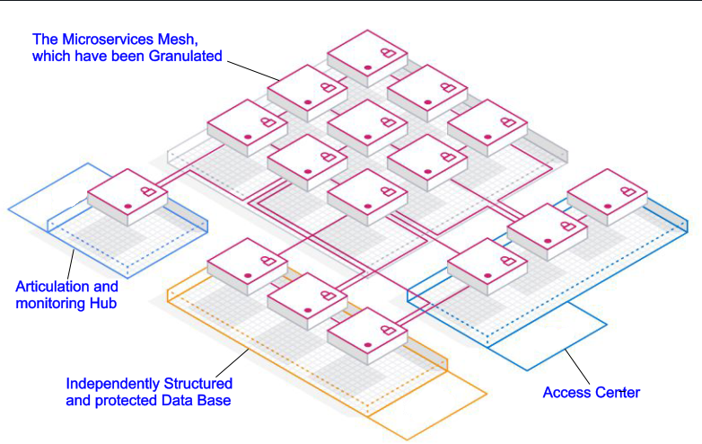

1. Granulated Network

Having observation points on the surface of the earth and out there in the open space have its own advantages and its drawbacks. Having system down on earth provides the versatility to use heavier and more sophisticated observation machineries like larger optics and star shades. Hoverer this is again contradicted by the interference of the earth’s atmosphere during the observation part. The various gaseous compositions spread out across the atmosphere cause variations in the light spectrums observed from distant stars. This is one of the main reasons behind the failure of the doppler effect as the spectrum gets heavily disrupted leading to false readings.

This one of the major reasons why the SHAPE module was deployed in the lunar orbit as that gives the whole system a way better vantage point in making observations, as there is very little hindrances from external sources. The only downside of a observation point out at space is the extreme modularity that the system should posses and the restrictions in its mass and size limits the capabilities of the technical hardware that can be compressed into these modules. The optical instruments used for deep space explorations have larger apertures which make them extremely hard to be integrated into these outer space systems and also the strict weight restrictions on the delivery payload also puts restrictions on how these systems are designed.

# The Proposed Sytem

With respect to the discussions regarding the various hindrances and backdrops faced by the above-mentioned methodologies, its proposed to create a system that would integrate all these five methodologies and use them in tandem. The creation of such a system would require both advance software and hardware components to be packed into a payload that could be successfully delivered to the outer space.

## Advanced CNN based image analyzers:

The images captured by direct imaging can be better analyzed by using specially weighted networks using the data captured by the SHAPE module as a point reference the weights of the neural network used to analyze these images can be preset to give it better chances for the network to identify possible exoplanets form these images. Having a reference dataset to train the model on what to look for can go a long way in increasing the overall efficiency of the system.

## How Digital forensic analysed the case:

Through careful examinations and recreations of the scenarios that led to the breach, it was identified that the stolen data from previous data breaches were used to systematically facilitate automated attacks on the zoom’s login API’s. The Automated system kept on this procedure and each time a login was successful, the system added the valid zoom credentials to an ever-growing list which was later sold on the dark web.

The analysis also identifies that one of the leading causes that played to the success of the above procedure was the fact that almost half of the users, 52% to be exact where found to be reusing the same password or repurpose, them with minor modifications. The possible solution that can be prescribed here is the usage of multifactor authentication systems to improvise the initial entry into the eco-system. It’s in scenarios like this that methodologies like Keystroke Dynamic Authentication Can be used to bring in a more sophisticated layer of protection to the eco-system.

## Attempts to take down dark web market places:

One of the most notable planned and well enforced attack that took place in the dark web was organized by the US Homeland security. [3] A team of over 200 domain experts, facilitated with the state-of-the-art technology and hardware support planned an attack on one of the most prominent market places in the dark web. After many brute force attacks and rapid infringement’s, they were finally able to take down the market place and seize all its transactions for a momentary period of time. Irrespective of this they were unable to track down the creator of this market place and his identity was yet to be traced out. During the initial downtime of the market place, many forensically aided studies were performed on the targeted market place, which exposed many of the illicit activities that where propagated through these portals, these included unilateral drug trades, arms trade just to mention a few. All these subordinated the large amount of breached data of top organizations that were up for sale in the platform. There were also open bids for hackers which invited them with attractive rewards for targeting a particular organization or an individual and targeting a cyber-attack on them.

## The Challenge:

Hours after the above-mentioned attack was carried out, the creator of the market place that was taken down came up with four additional market places, which brought back all the illicit activities back into active operations. This was a clear eye opener that demonstrated how well organized and protected these networks were. Even though it’s hard to digest, we have to accept the fact that the individuals who are indulged in the world of dark web are more technically sound regarding the working principles and domains of the environment in which they have been thriving this far in and the undermining fact that there are a lot more researches and analysis that has to be brought in to facilitate a more goal-oriented attack. Another factor that has to be taken into consideration is the extent of anonymity that the dark web offers to its users, which encourages them to take up illicit activities without ever having to worry about the possibilities of getting caught or jeopardized. The initial steps of accessing the dark web involves the usage of a circuitry network which will help the user to keep his IP address and location hidden behind a pair of spoofed credentials. One of the most commonly used ones are the Tor Circuitry networks, which can be used in conjecture with the tail operating system for an all-in planned interface.

Adding to this, most of the market places in the dark web make use of encrypted web domains which comprises of a set of 25 characters ranging from alphabets, numbers, special characters etc., which are arranged in complete random orders, without any logical connection. These market places also change their domain address on a daily or hourly basis, or whenever they feel like an external force is trying to breach the eco-system. The updated domain addresses are only shared with the active members of the network through their own secret mode of communications that are facilitated within the dark web.

# The possible correlation conjectures

Many of the features discussed in this paper were from the point of view of each of the domains that where discussed, and it’s highly evident that they have their own independent use cases and importance. The Following are ways in which a possible conjecture can be formed.

## Analysis of digital forensic using Zero trust principles :

This believes in the usage of an investigation strategy which are inspired by the zero-trust principle of considering every aspect or request as a threat. This principle when converted into the aspects of forensics derives [4] a strategy adopted by investigators which defines the ground rule that all the devised aspects of the investigation are deemed to be unreliable until and unless verified by the necessary proofs and evidences. This helps the analyst to perform more validated post attack studies of the system, which will subsequently help in the unearthing of possible weak points, which can be enforced in the future for better results.

## Identification of harmful insider activites :

This aspect of data breach is often the most unpredictable and the most destructive with respect to a business organizations integrity and reputation. One such prime example of this happened when a former employee of AWS breached more than 100 million data records belonging to the Capital One financial organization. The employee was able to undergo the hack by creating a tool that could search for misconfigured AWS accounts. Through this, the hacker was able to gain access to more than 30 organization’s AWS accounts which resulted in the breach of highly confidential data including banking details like credit limits, balances, contact information, payment history etc. Digital forensics in collaboration with zero trust could have prevented this from happening by using the granulation methodology and least data access privileges protocols.

## The Dark Web Forensics :

There is still a lot more to be understood and researched about the domain of dark web and this can be achieved by using the principles of digital forensics. This can enable us to understand the main illicit vectors that drive the platform’s ever-growing popularity among cyber criminals. The first step would be to identify the many use-cases that are satisfied through this domain.

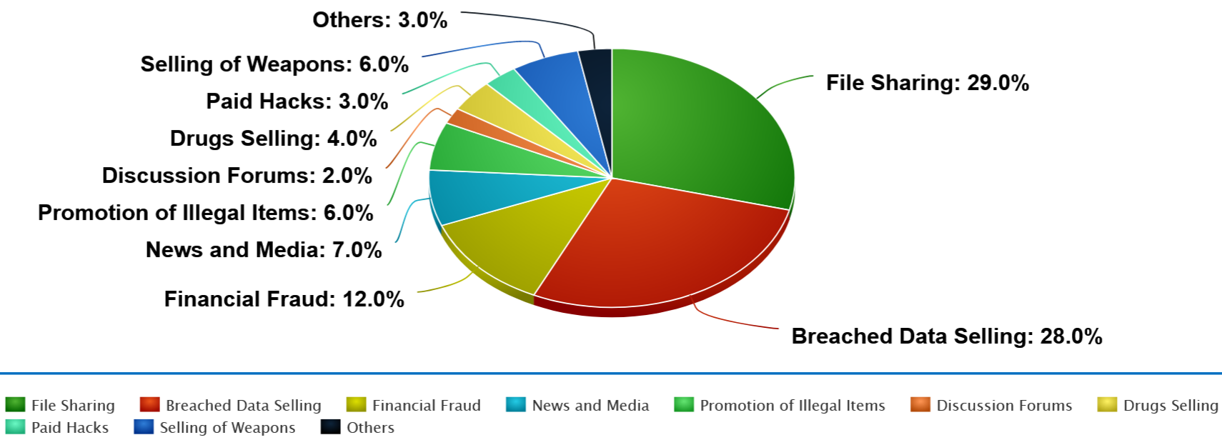

1. The Use-case pie

With respect to the analytics that can be infered from the above graph its clearly evident that Breached data selling plays the role of the main drive force for the populartiy of the domain, this in conjucture with the extreme anonymity provided by the eco-system provides a boost to all of the illicit vectors that are represented in the Pie chart in Fig.4. The active creation and spread of child pornographic contents is also an rising social evil that’s being empowered by the domain of dark web. This has further led to the creation of communities with the darkweb for groups of users who are indulged in activites of common interest. Further detailed forensic investigations into the domain can help us in devising future attacks and endevours that might be able to fight the social evil, that still continues to grow in through the domain.

## The Framework :

With respect to the various individual aspects discussed above, we are able to arrive at a possible hypothetical framework, which is demonstrated in Fig. 5.

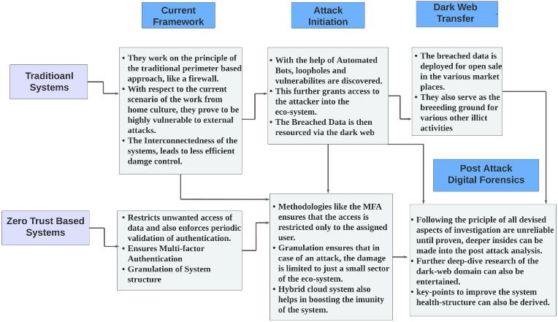

1. The Framework

# Conclusion and future scope

Encapsulating all the key points that has been discussed and pondered upon for this paper we have arrived at the following conclusions and future scope.

## Importance of Zero Trust:

In this rapidly digitalizing world, the need for better cyber security protocols and methodology that can stand up against these attackers are the need of the hour

## Efficiency and Efficacy:

With respect to the real-world applications which require the need for users to safely access their respective eco-systems from any possible networks can be made possible by the usage of Zero trust protocols as they are not perimeter or location-based approaches.

## Affordability / Cost Effectiveness:

In accordance with the current scenario, it’s upto the organizations to decide whether to hire a third-party organization to facilitate zero trust services or to build an integration of their own, which would again help the organization to keep the data closer to themselves.

## Flexibility and Robustness:

Zero trust can be easily integrated into any existing system by undergoing minute modifications in the central network that connect the various individual components including the API’s. Moreover, it’s more efficient to eco-system from scratch keeping the principles of Zero Trust in mind.

Through the various Market studies and background researches that went into the making of this paper it’s clearly evident that there is a huge scope for developments in the field of Digital forensics aided with the continuous development in the protocols associated with zero trust. Determination of weak points and a psychological analysis of the users of the system can also be kept as a scope for further research into the field, as dark web also acts as a breeding ground for pedophiles and other anti-social thinkers. There are in depth research to be done in the field of Dark Web which has mostly been ignored as an unchartered domain and often untouched by researchers due to the subdued fear of reverse attacks by cybercriminals within the domain. Nevertheless, it’s absolutely necessary to realize the fact that in order to stop any social evil it is necessary that we try to eliminate or attack the very source of the social evil, and in this case line of attack is to be targeted upon the domain of Dark web.

##### References

1. The Cost of a Data Breach Report by Eain on behalf of IBM Cybersecurity reports, August 1,2022
2. What is Hybrid Cloud, The report by RedHat Cyber solutions October 20,2012
3. A public policy perspective of the Dark Web by Michael Chertoff for journal of cyber policy March 2017
4. The case for Zero Trust Digital Forensics By Christopher Neale, Ian Kennedy, Blaine Price, Yijun Yu, and Bashar Nuseibeh March,2022